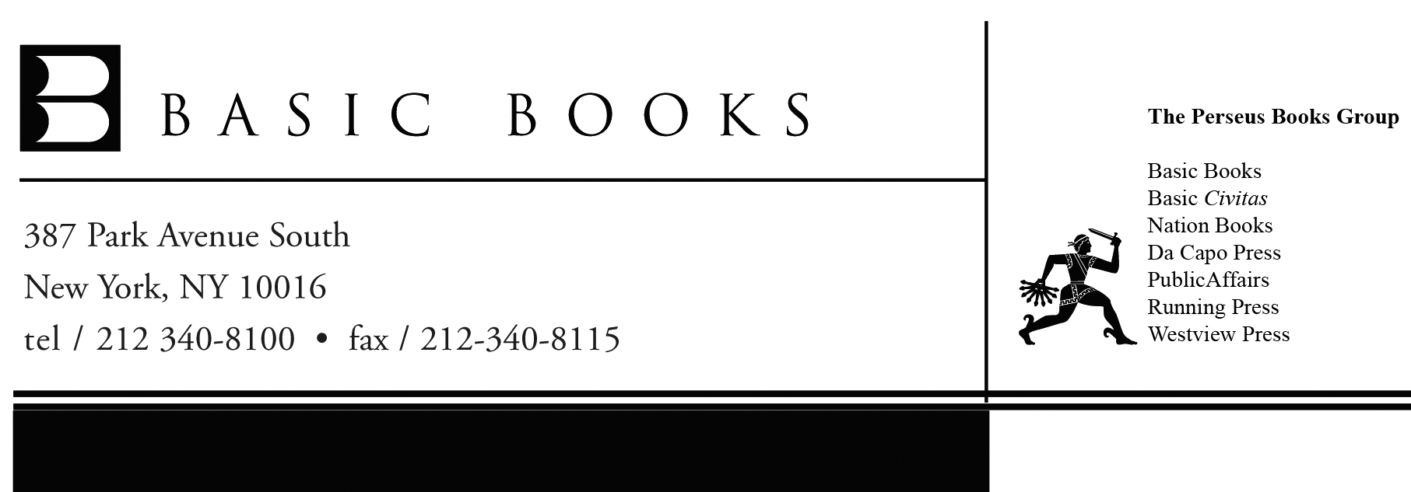

FOR IMMEDIATE RELEASE Contact: Cassie Dendurent Nelson
212-340-8132 or cassie.nelson@perseusbooks.com

“The Shape of Inner Space provides a vibrant tour through the strange and wondrous possibility that the three spatial dimensions we see may not be the only ones that exist. Told by one of the masters of the subject, the book gives an in-depth account of one of the most exciting and controversial developments in modern theoretical physics.”
—Brian Greene, Professor of Mathematics & Physics, Columbia University,
author of The Fabric of the Cosmos and The Elegant Universe

“This remarkable book by Shing-Tung Yau and Steve Nadis gives the layman a remarkable glimpse into the mysterious inner world of one of the most beautiful and important parts of mathematics.”
—John Coates, Sadleirian Professor of Pure Mathematics, University of Cambridge

THE SHAPE OF INNER SPACE:
String Theory and the Geometry of the Universe’s Hidden Dimensions
By Shing-Tung Yau
Winner of the Fields Medal
and Steve Nadis

There’s more to the universe than we can see: About 96% of the universe consists of dark energy and dark matter that’s not only mysterious but invisible. Only 4% of the universe consists of regular matter, the stuff that we’re made of, and most of that is so far away – and accelerating even farther away from us due to dark energy – that we’ll never be able to see that either. But what about things close at hand, close enough to touch? Might there be, at every spot we can point to, a hidden, multidimensional realm that is too small to see? A place that exists everywhere we turn, and exerts a powerful influence on the physical world all around us, yet is so miniscule that we could never step inside and look around?

This provocative notion comes from string theory, which is the most promising idea physicists have yet devised in their attempt to explain everything in the universe. In this theory, the concealed multidimensional realm – which is tucked away at every single point in our ordinary world – comes in the form of convoluted six-dimensional shapes called Calabi-Yau manifolds. In THE SHAPE OF INNER SPACE: String Theory and the Geometry of the Universe’s Hidden Dimensions (Basic Books; September 7, 2010), Shing-Tung Yau – the man who proved the manifolds’ mathematical existence – and science writer Steve Nadis explain how this intricate geometry found its way into the center of what is currently our leading theory of nature.

At the heart of THE SHAPE OF INNER SPACE is a tale of how physics met geometry and the new picture of the universe that has emerged as a result. In 1976, Yau proved the existence of the “Calabi conjecture,” which demonstrated the existence of strange, higher-dimensional spaces that are now called “Calabi-Yau manifolds.” In doing so – an effort that took several years – he not only proved the Calabi conjecture, but also proved several other theorems of mathematical importance.

Explaining how geometry is crucial to our understanding of the physical world – an idea embraced by both Plato and Einstein – THE SHAPE OF INNER SPACE shows how Yau’s geometric forms caught the attention of physicists and have since become vital to string theory and cosmology. Eight years after Yau’s proof, string theorists independently posited that the universe has six “extra” dimensions, the shape of which dictates pretty much everything – all the particles and all the interactions between them. While searching for the right geometry, these physicists realized that Calabi-Yau spaces might meet all their requirements. These geometrical spaces, in other words, might provide “the shape of inner space.” The Calabi-Yau manifold instigated a revolution – and no shortage of controversy – in physics, as string theorists used it to try to justify their two big ideas: that the particles that make up all matter are themselves made up of vibrating strings, and that those strings vibrate in ten (or more) dimensions.

Looking forward, Yau and Nadis also describe the ongoing exploration of Calabi-Yau spaces and the quest to uncover the shape of this hidden, “internal” domain that may govern almost everything in our universe. They note, however, that Calabi-Yau spaces aren’t necessarily the last word or that we even live in such a space. “The study of these manifolds has enabled physicists and mathematicians to learn many interesting and unexpected things, but these spaces can’t explain everything; nor can they take us everywhere we might conceivably want to go.”

Showing readers what exists at this intersection of calculus, topology, and geometry, THE SHAPE OF INNER SPACE explains the mathematical machinery behind string theory, leaving readers with provocative ideas on what the future might hold for physics, mathematics, and the universe itself.

ABOUT THE AUTHORS
Shing-Tung Yau has been a professor of mathematics at Harvard since 1987 and is the current department chair. Yau is the winner of the Fields Medal, the National Medal of Science, the Crafoord Prize, the Veblen Prize, the Wolf Prize, and a MacArthur Fellowship. A member of the National Academy of Sciences, Yau has written and edited more than twenty books. He lives in Cambridge, Massachusetts.
Steve Nadis is a contributing editor to Astronomy magazine. A graduate of Hampshire College, he has written or contributed to more than two dozen books. Nadis has also been a research fellow at MIT, a staff researcher at the Union of Concerned Scientists, and a consultant to the World Resources Institute, the Woods Hole Oceanographic Institute, and WGBH/NOVA. He lives in Cambridge, Massachusetts, where he is also the humor columnist for the Cambridge Chronicle.

ABOUT THE BOOK
THE SHAPE OF INNER SPACE:
String Theory and the Geometry of the Universe’s Hidden Dimensions
By Shing-Tung Yau and Steve Nadis
Published by Basic Books
Publication date: September 7, 2010
ISBN: 978-0-465-02023-2 • $30.00 • 400 pages
www.shapeofinnerspace.com

For additional information about THE SHAPE OF INNER SPACE and other Basic Books,
visit us online at www.basicbooks.com or follow us on Twitter at @BasicBooks.
Advance praise for
THE SHAPE OF INNER SPACE:
String Theory and the Geometry of the Universe’s Hidden Dimensions
By Shing-Tung Yau and Steve Nadis
(Basic Books; September 7, 2010)

“With the help of Astronomy magazine contributing editor Nadis, Yau relates the saga of [his] groundbreaking work which provided the foundations of string theory. Yau confidently draws readers into a realm of abstract concepts, from multiple dimensions to the exotic spaces called ‘manifolds,’ or Calabi-Yau spaces, whose curvature gives space its shape. From here it’s a hop, skip, and a jump to the geometry of space around the Big Bang, black holes, and the end of the universe.”
—Publishers Weekly

“This remarkable book by Shing-Tung Yau and Steve Nadis gives the layman a remarkable glimpse into the mysterious inner world of one of the most beautiful and important parts of mathematics.”
—John Coates, Sadleirian Professor of Pure Mathematics, University of Cambridge

“The Shape of Inner Space provides a vibrant tour through the strange and wondrous possibility that the three spatial dimensions we see may not be the only ones that exist. Told by one of the masters of the subject, the book gives an in-depth account of one of the most exciting and controversial developments in modern theoretical physics.”
—Brian Greene, Professor of Mathematics & Physics, Columbia University, author of The Fabric of the Cosmos and The Elegant Universe

“Einstein’s vision of physical laws emerging from the shape of space has been expanded by the higher dimensions of string theory. This vision has transformed not only modern physics, but also modern mathematics. Shing-Tung Yau has been at the center of these developments. In this ambitious book, written with experienced science writer Steve Nadis, Yau tells of his own mathematical experiences, and of the parallel efforts in string theory and in mathematics to understand the nature of space.”
—Joe Polchinski, Professor of Physics, University of California, Santa Barbara; author of String Theory, Vols. 1 & 2

“The Shape of Inner Space has a distinctive style: in part autobiography, in part an account of developments in geometric analysis and string theory over the past 40 years, and comments on future directions. It gives a unique insight into the thoughts of one of the most important and influential mathematicians of our times.”
—Simon Donaldson, Royal Society Research Professor in Pure Mathematics and President of the Institute for Mathematical Science, Imperial College London

“Shing-Tung Yau and Steve Nadis take the reader on a fascinating tour of many contemporary topics in geometry and physics. Readers will find many challenging ideas to explore in this book, and even specialists will enjoy Yau’s reminiscences about his education and work.”
—Edward Witten, Professor, Institute for Advanced Study

“A fascinating first-hand account of how the math underlying string theory was discovered. Fields medalist Yau and ace science writer Nadis have teamed up to show the rest of us the deep geometry that just might lie at the heart of the universe. It’ll twist you into knots of pleasure!”
—Steven Strogatz, New York Times Opinionator contributor and professor of mathematics, Cornell University
# # #

